|  |  |
| --- | --- |
|  |  |

**Semester 2 2022/2023**

**MCSD1143 - Supply Chain Analytics**

**Project Proposal**

**Group Members**:

1. Ali Abdulkadir Arale (MCS191024)
2. Chong Xian Jun (MCS211047)
3. Tan Fei Zhi (MCS221016)

**Lecturer:** Dr. Nor Erne Nazira Binti Bazin

# **Background of Project**

Demand forecasting plays a crucial role in supply chain management and business planning. By accurately predicting future demand, organizations can optimize their inventory levels, production schedules, and distribution strategies. In the context of the Norwegian automotive industry, demand forecasting is essential for automakers, dealerships, and policymakers to make informed decisions and meet the evolving needs of consumers.

The selected dataset is New Car Sales in Norway, obtained from Kaggle. The dataset is derived from the annual presentation "Car Year 2016: Status and Trends" conducted by Opplysningsrådet for Veitrafikken (OFV), which provides valuable insights into the demand for new passenger cars in Norway. The presentation highlights the significant increase in sales of electric cars, with electric and plug-in hybrid vehicles accounting for 40.2% of all new car sales in 2016. This data reflects the growing popularity of battery-equipped vehicles in Norway, surpassing other countries like Sweden and Denmark in terms of market share. This project focuses on analyzing and forecasting the electric car market in the Norwegian automotive industry. Additionally, the project aims to identify the best-selling electric car models in Norway and predict their sales trends.

**Objectives**

This analytics project is to gain insights on the electric car market in Norway by analyzing and forecasting its trends, thereby informing the stakeholders to make better decisions accordingly. The analytics is broken down into 3 parts, i.e.

1. To analyze and forecast the electric car market in Norway.
2. To understand the effect of electric car adoption on the CO2 emission trend, thereby predicting the future trends of car emissions in Norway.
3. To find out the electric car models that sell the best in Norway and predict their sales trends.

# **Data Source**

<https://www.kaggle.com/datasets/dmi3kno/newcarsalesnorway?resource=download>

The dataset includes 3 tables:

1) Monthly sales of new passenger cars by make (manufacturer brand) - **norway_new_car_sales_by_make.csv**

* Year - year of sales
* Month - month of sales
* Make - car make (e.g. Volkswagen, Toyota, Tesla)
* Quantity - number of units sold
* Pct - percent share in monthly total

2) Monthly summary of **top-20** most popular models (by make and model) - **norway_new_car_sales_by_model.csv**

* Year - year of sales
* Month - month of sales
* Make - car make (e.g. Volkswagen, Toyota, Tesla)
* Model - car model (e.g. BMW-i3, Volkswagen Golf, Tesla S75)
* Quantity - number of units sold
* Pct - percent share in monthly total

3) Summary stats for car sales in Norway by month - **norway_new_car_sales_by_month.csv**

* Year - year of sales
* Month - month of sales
* Quantity - total number of units sold
* Quantity_YoY - change YoY in units
* Import - total number of units imported (used cars)
* Import_YoY - change YoY in units
* Used - total number of units owner changes inside the country (data available from 2012)
* Used_YoY - change YoY in units
* Avg_CO2 - average CO2 emission of all cars sold in a given month (in g/km)
* Bensin_CO2 - average CO2 emission of bensin-fueled cars sold in a given month (in g/km)
* Diesel_CO2 - average CO2 emission of diesel-fueled cars sold in a given month (in g/km)
* Quantity_Diesel - number of diesel-fueled cars sold in the country in a given month
* Diesel_Share - share of diesel cars in total sales (Quantity_Diesel / Quantity)
* Diesel_Share_LY - share of diesel cars in total sales a year ago
* Quantity_Hybrid - number of new hybrid cars sold in the country (both PHEV and BV)
* Quantity_Electric - number of new electric cars sold in the country (zero emission vehicles)
* Import_Electric - number of used electric cars imported to the country (zero emission vehicles)

*Note: The numbers on sales of hybrid and electric cars are unavailable prior to 2011.*

Data up to 2015 is used for model development, 2016 for forecast model testing.

# **Analytics Method**

Forecast methods are developed via experimentations:

E.g. Holt-winter’s model, exponential smoothing etc

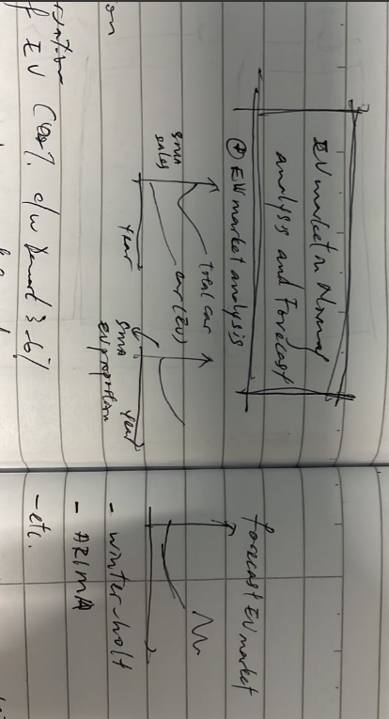

* + - 1. Ev market analysis. So, we can have 3 plots: firstly, the trend of total car sales compared to EV car sales (quantity). Secondly, the trend of the EV market share (percentage). And thirdly, the forecast for both EV quantity and percentage.

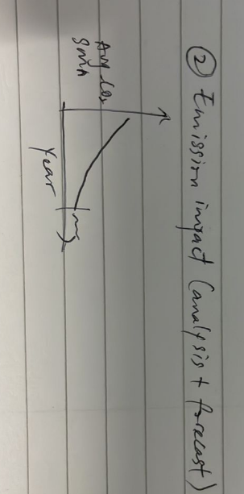

2. Emission analysis- can be conducted with Avg_co2 (from third table) * car sales. Not sure now but we’ll see how

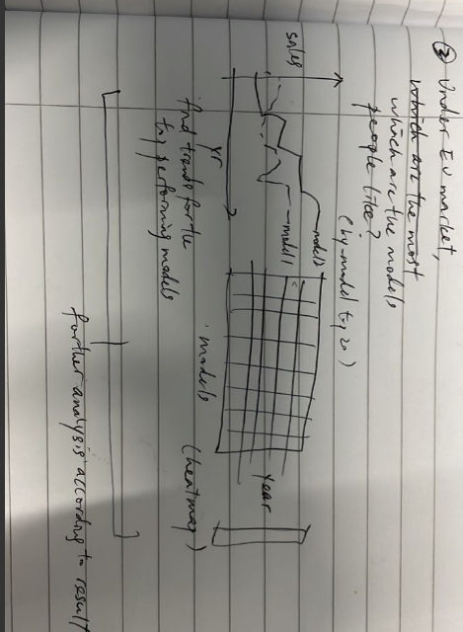

3. Within the Norwegian EV market, which models are the most favored? (Refer to Table 2)